Dr. Jane Burns, UCSD Medical Center
Treatment of Kawasaki Disease

Parents’ Symposium,
Cardinal Glennon Hospital, St. Louis
March 29th2003
My charge today is to talk to you about treatment of Kawasaki Disease. I am going to give you a very brief overview and also touch briefly on the treatment that we use for children once the aneurysms have formed.

PP1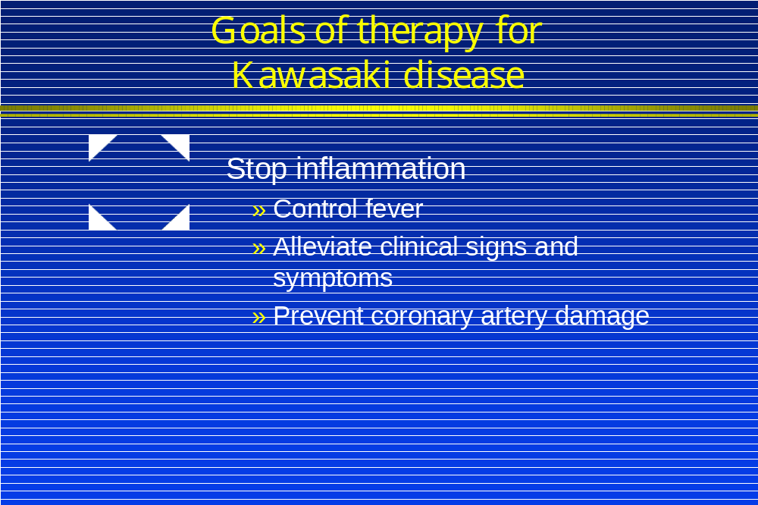

The main goal of therapy has always been to stop inflammation during the acute phase of Kawasaki Disease. So that’s really our goal. And, over the years, all of the strategies that we have used have been aimed at trying to stop the inflammation.

The fever that all of you were so keenly aware of during the acute illness of your child is a manifestation of the immune response that Dr. Shulman talked with you about; and controlling the fever and using the fever as a sign that we’re being successful in controlling the inflammation is very important. We consider children to have responded to our therapy when the fever goes away.

We also, of course want to alleviate the clinical signs and symptoms, which are very troublesome to the child, and worrisome to us. But the bottom line of all of this is that what we are trying to achieve here is the prevention of the coronary artery damage.
PP2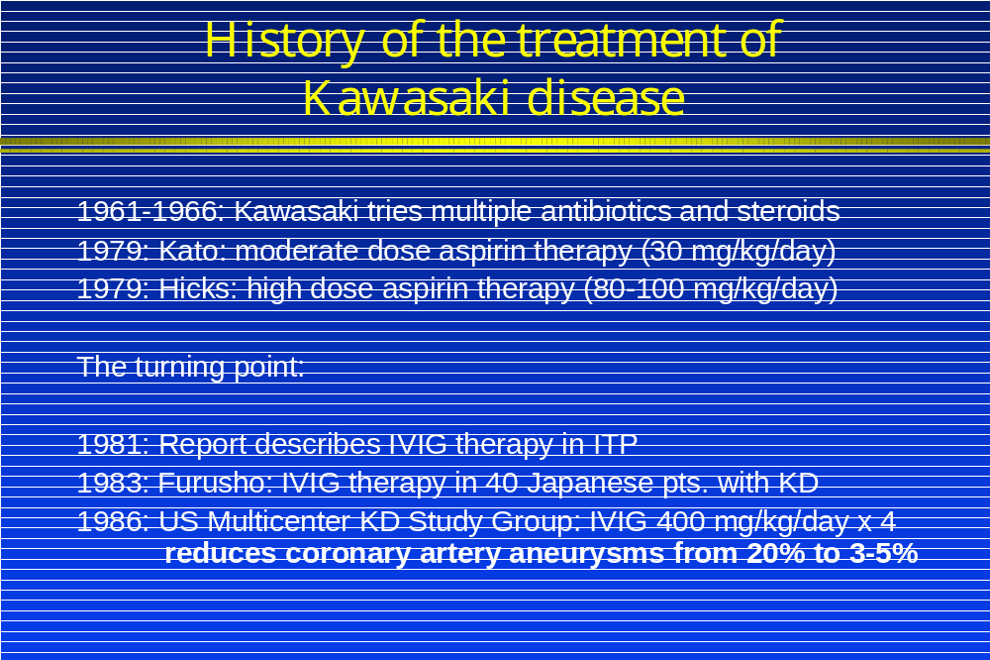

I thought it might help to get a little bit of the history of this disease, I know some of you have children who had Kawasaki Disease in the era before we had gamma globulin therapy, so I just thought I’d bring you up to date a little bit on how we got to where we are today.

In the early days, Dr. Kawasaki saw his first patient, although he didn’t appreciate it was his first patient, in 1961. And then over the subsequent period up until 1966 he collected 50 patients and published them as a series about a year later.

Dr. Kawasaki tried multiple different kinds of therapies that were available at the time, and specifically multiple kinds of antibiotics. Those of us who look at history and try to let history teach us, look at the broad range of antibiotics that were used by Dr. Kawasaki, which include some unusual classes of antibiotics that aren’t widely used today such as chloramphenicol. And none of these antibiotics, the tetracyclines, the erythromycins, or chloramphenacol seemed to have any effect on the clinical course of a patient. One could use this fact to argue that KD is probably not caused by a bacteria, or at least not a bacteria that’s actually present at the time of the child is sick.
Dr. Kawasaki also used steroids in these patients, and it was hard to evaluate what the effect of that was.
One of the preeminent Japanese cardiologists, Dr. Kato, was the first in 1979 to advocate using a moderate dose of aspirin therapy, and he showed that this could shorten the fever. And then Marian Melish working with Raquel Hicks the Rheumatologist at the University of Hawaii found that using high dose aspirin was helpful in these patients. It’s really from their original work back in 1979 that we still have aspirin therapy as part of the mainstay today used with gamma globulin.
So how did we get to gamma globulin? It was a real turning point in 1981 with the publication of a paper using gamma globulin, which was a newly available product.

Gamma globulin is an anti-body-rich preparation, made from human plasma. But it was originally prepared in such a way that it could not be give in high doses intravenously. And so there were some technical breakthroughs that allowed us to really be able to concentrate it and make it safe to give intravenously.

And this was first tried, or first widely publicized, for treatment of the immunologic disease that causes low platelet counts, it’s called ITP or Idiopathic thrombocytopenic purpura but we’ll call it ITP. And this article was published in a journal called the “Lancet” in 1981 it’s widely read throughout the world and was seen by the Japanese. This was before the age of the Internet, when things were really widely available through your computer.
This article, was actually read by several Japanese investigators who independently tried this in Kawasaki Disease, patients for various different reasons, they thought it might be effective. And, Dr. Kensi Furusho was the first to treat a fairly large series of KD patents. He published his experience in 1983. At that time I was in Boston with my colleague Jane Newburger.

And together Dr. Newburger and I thought about trying to study this therapy that the Japanese had described and seemed to be very effective in Japanese children with Kawasaki Disease.

Of course treatments that work on Japanese children may or may not necessarily work on American children just because of differences in genetic background, so we felt it was very important to do a multi-center trial in this country. And so Jane Newburger and I designed the multi-center trial that brought together Stan Shulman, Marian Melish, Mike Takahashi and several other colleagues from, a broad geographic distribution across the United States and this was the US. Multi-center KD Study Group.

The most important finding from our study was that we could reduce the incidence of coronary artery aneurysms from roughly about one in five to only 3-5%. So it wasn’t perfect, but it was certainly a huge advance over what we had had before.
PP3 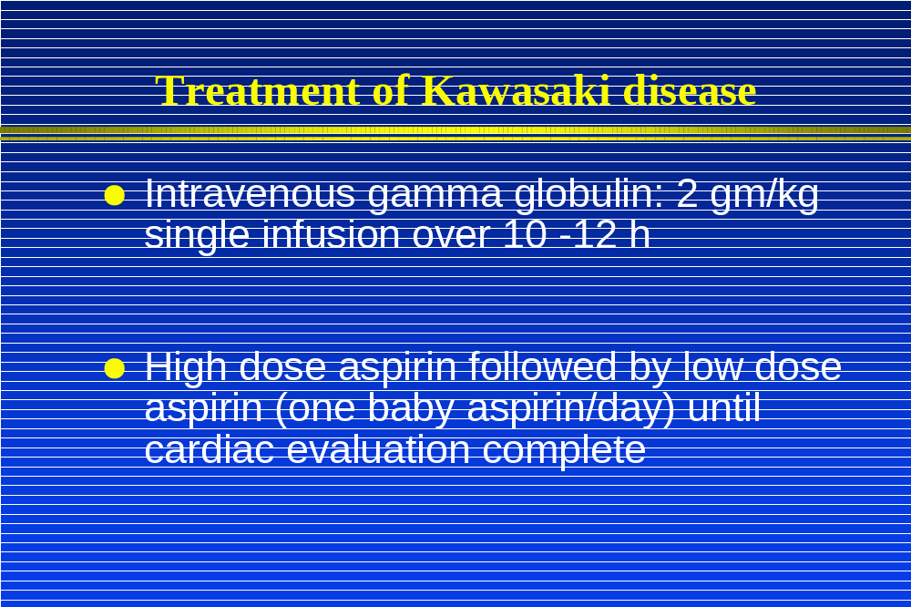

Currently, we give a large dose of intravenous gamma globulin in conjunction with high-dose aspirin, which is given for a period of time until the inflammation and fever are controlled, and then switched to low-dose aspirin, which really is a different purpose. With low dose aspirin we’re really trying to prevent any blood clots from forming.
PP4 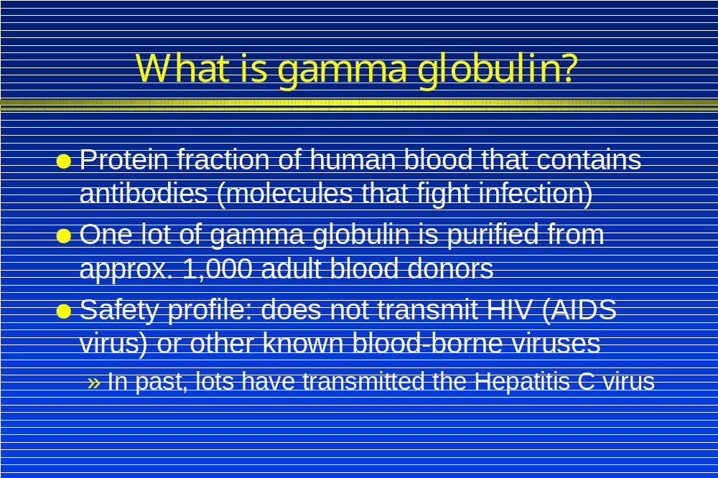

So what is this gamma globulin, this magic treatment for Kawasaki Disease? It is a protein fraction of human blood that contains the antibodies, or infection-fighting molecules that the body makes. To make one lot of gamma globulin takes about 1,000 blood donors. This is a very expensive resource and it’s a very limited resource. You know we’re lucky to live here, in the United States in many ways. And one of the things is the availability of gamma globulin. We need to remember that in the community where I work, San Diego, our neighbor to the south, Mexico, does not have gamma globulin available for treatment of children with this disease. Nor is it available in large parts of China, the Philippines, and many other countries throughout the world.
In terms of a safety profile we always worry when something is purified from human blood. Certainty the experience of the AIDS virus, has us all a little nervous. However very careful experiments have been done that show that it is not possible to transmit the AIDS virus with this preparation because of the manufacturing process,. However in the past there have been lots of gamma globulin that were contaminated with another very terrible virus called the Hepatitis C virus.

The screening procedures for blood and manufacturing techniques were adjusted since these problems occurred. And fortunately I’m not aware of any Kawasaki Disease patients who received the contaminated lots of gamma globulin. But obviously I think if we could get away from this therapy and come up with something that would be more generally available and that would be less expensive, that would be very desirable.
PP5 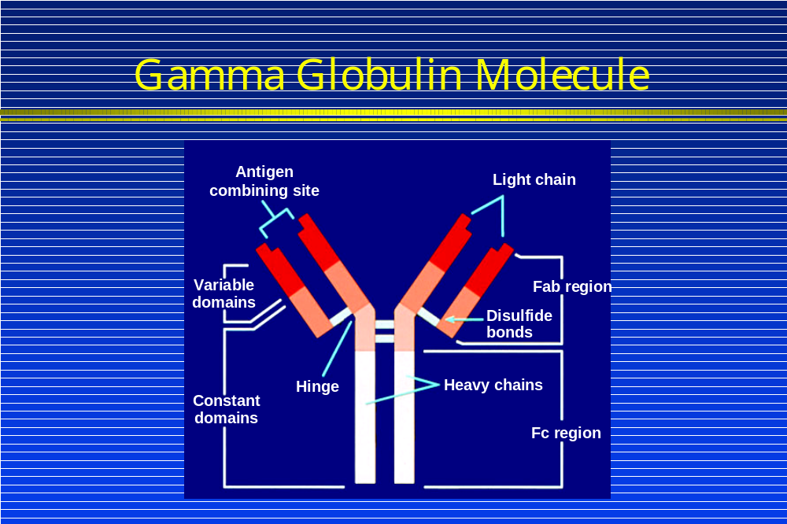

This is what a gamma globulin molecule looks like. The business part of the molecule is here where it combines with, the antigen, which is its target. The antibody/antigen complex can then be cleared from the body.

How this molecule actually works in Kawasaki Disease though may have more to do with the constant domains. These are all areas of research in our laboratory and others to try to understand a little bit better how gamma globulin works. If we understood better how this therapy works, it might help us to design other more specific treatments.
So, one of the ideas that we have about how gamma globulin works is that it reduces the cross-talk among all of the cells of the immune system. Another possibility is that it really contains antibodies harvested from the adults who donated the blood used to make the gamma globulin. Remember that adults almost never get Kawasaki Disease. So why is it that we are protected? Are we immune?
And if we are immune, then that means we have specific cells as well as antibodies in our body that protect us. So maybe there is specific antibody to this KD agent or agents.
And there may also be antibodies here that bind to other molecules of the body that are part of this inflammatory process. And finally we suspect that it also binds to receptors on the surface of cells and particularly the cells that line the blood vessels and it prevents interaction with other cells and cells leaking out and getting into the blood vessel walls.

PP6 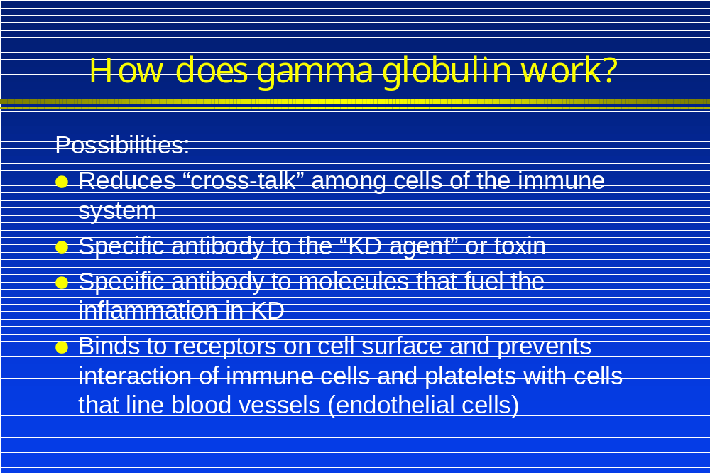

So what we want the Gamma Globulin to do is perhaps bind to some of these receptors and cut out this cross talk that is fueling the inflammation in Kawasaki Disease.
PP7 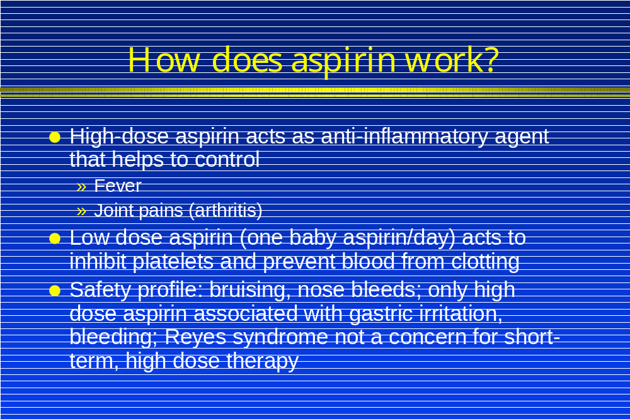
So how does aspirin work? We know that high dose aspirin does help in some way to control the fever and inflammation. And probably it helps with joint pains that are associated with the acute phase of the disease. But low dose aspirin inhibits platelets that are the sticky cells in the blood that are responsible for blood clots
The major side effects are bruising and nosebleeds. The high doses of aspirin that are given for short period of time at the beginning of the illness can be associated with irritation to the lining of the stomach and cause gastric bleeding problems. Reye’s Syndrome is a very serious condition that can occur when children take high dose aspirin when they are infected with the chickenpox or influenza virus. Reyes syndrome was essentially eliminated when we stopped using aspirin therapy for control of fever in children.
We have only seen the complication of Reye’s Syndrome in two Kawasaki Disease patients that I’m aware of. In both cases it was a miscommunication between the physician and the parents and the child was actually left on high dose aspirin for a very prolonged period of time.
So we try to keep the period of exposure to the high dose aspirin short. Just during the acute phase when they really need it for control of the inflammation. And I think it poses very little risk, used in that way.

So IVIG is a great therapy but not everyone responds. And these are some data about gamma globulin success and failure.
PP8 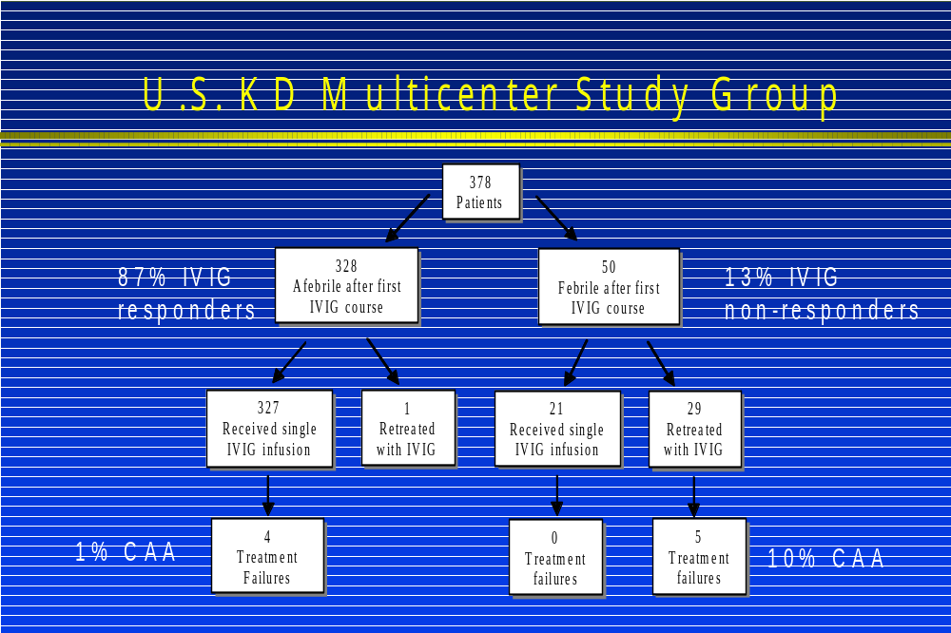
So these data were pooled from all the centers in the multi-center, Kawasaki Disease study group. There were 378 patients in this particular study and we see that 87% of patients responded to a single dose of IVIG here and that 13% that did not respond. And what I want to point out is that most of the children who went onto develop coronary artery aneurysms were in the group of non-responders.

I’m going to move on now from the acute treatment to issues that we try to address when damage has occurred. Most of you who have children with aneurysms are probably very familiar with a picture of the heart and what it looks like.

So what do we do in a situation with these aneurysms? Well, what we want to do is we want to prevent clots from forming. That’s really the biggest concern. We want to give the vessel a chance to heal.
PP10 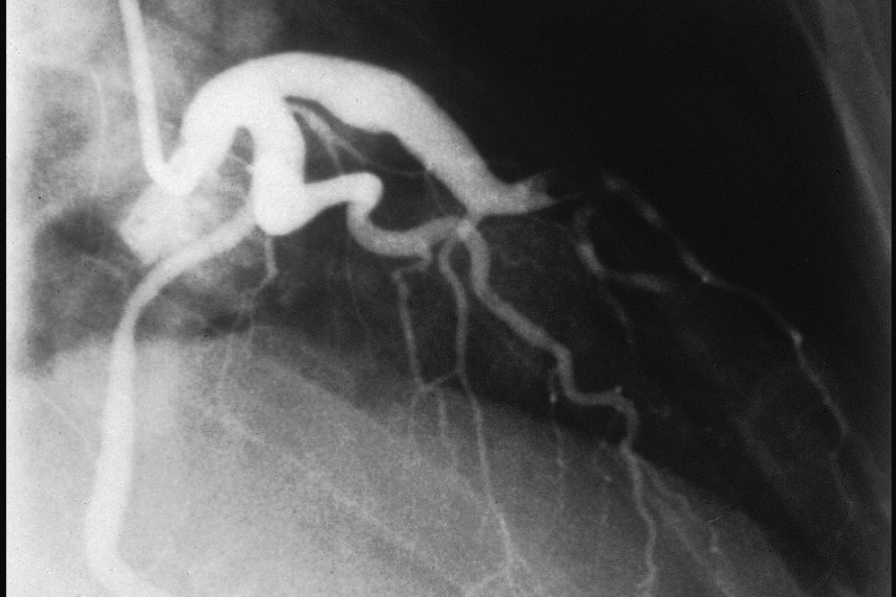
Blood clot blocking coronary artery

This is a picture of a dye injection into the coronary arteries of a 42-year-old, who suffered a heart attack when a big blood clot formed in the big, dilated branch of the left coronary artery. This happened to this gentleman who actually didn't know that he had Kawasaki Disease as a child; he was actually a triathlete and was very vigorous and healthy until he suffered this massive heart attack.

Because this individual didn’t now that he had had Kawasaki Disease, he was not taking any medication to prevent clots from forming. So this heart attack was potentially preventable, even in someone who has big dilated blood vessels like this. With the proper management and careful follow-up and work with your cardiologist, this kind of problem can usually be prevented.

PP11 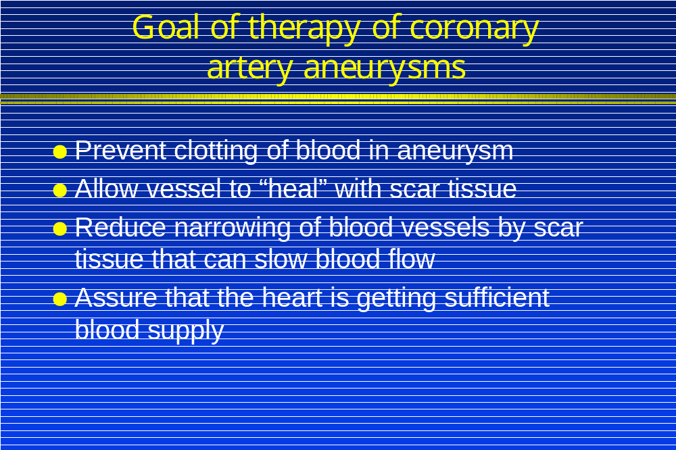

The main goal is to prevent clotting in the aneurysm. This we hope will allow the vessel to heal. We want to reduce the narrowing of blood vessels by scar tissue that can slow the blood flow and that narrowing can be a significant problem. It is important that the heart muscle is getting an adequate blood supply from these arteries.
PP12 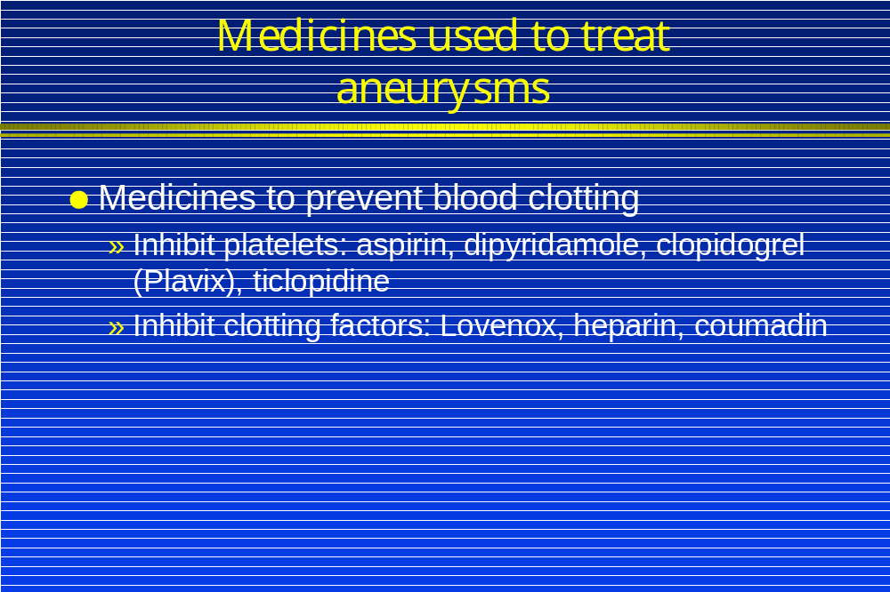

There are a number of different medicines that can be used and I will not go into detail because the use of these medicines is always through a pediatric cardiologist, and it’s very individualized. We do have ways of inhibiting the platelets and preventing them from clotting. This includes a new group of medicines that are just coming into use. These are medicines that have been used extensively in adult populations and we are just beginning to learn about them and how to use them in pediatric patients.
The other mainstay of treatment for children with very large aneurysms is to inhibit the protein factors in the blood that cause blood clots. This is achieved with medicines such as warfarin or Coumadin or heparin.

