“Fund-A-Need”
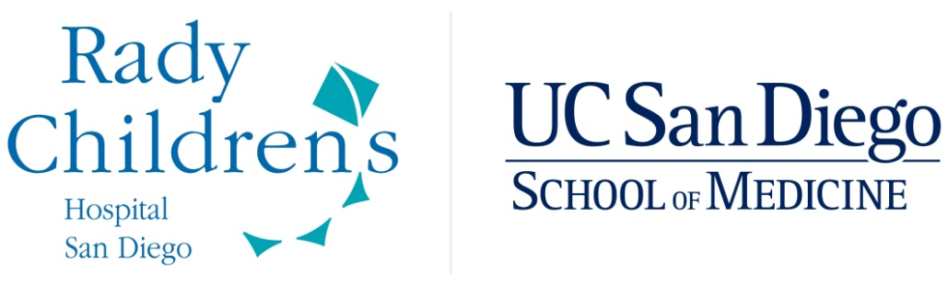
Kawasaki Disease Research Center

Kawasaki Disease Research Center

The Kawasaki Disease Research Center (KDRC) is a joint collaboration between the Departments of Pediatrics, Medicine, Chemistry, Engineering, and Sociology at UC San Diego, Scripps Institute of Oceanography, and Rady Children’s Hospital San Diego. The Center was created to help foster excellence in care for patients with Kawasaki Disease (KD), and to support clinical, laboratory, and epidemiologic investigation into the etiology, pathophysiology, genetics, immunology, treatment and natural history of the disease. The Center brings together investigators and physician scientists from Japan, Western Europe, and the United States with diverse research interests and expertise to work together to further the understanding of this enigmatic disease.

Kawasaki Disease (KD) is:
- Most common cause of acquired heart disease in developed world.
- Acute illness symptoms include fever, rash, red eyes, red lips, red hands and feet.
- Symptoms will cease after 1-3 weeks, even without treatment.
- When untreated, 1 in 4 children will develop irreversible, potentially fatal, damage to the blood vessels that supply the heart muscle (coronary arteries).
- The weakening of the blood vessel wall causes a ballooning out of the wall called an aneurysm.
- If caught early, KD is treatable with a high dose of intravenous immunoglobulin or IVIG (the protein fraction of human blood that contains the antibodies).
- Most children in the world with KD are never treated because IVIG is expensive and/or is not readily available in many countries.
- If not diagnosed in childhood, the coronary artery aneurysms remain silent until adulthood when a clot may form in the aneurysm causing a heart attack.

Supporting Research, Discovery and a Cure is just a click away:

If you are an individual interested in making an immediate difference through philanthropic support, please go to the website www.pediatrics.ucsd.edu/kawasaki and click on the “Donate Now” button. Your gift will be immediately deposited into the UC San Diego Foundation account for the KDRC after a one-time fee of 6% is deducted for indirect costs. Your donation is 100% tax-deductible and you will receive a formal acknowledgement and receipt of your gift for tax purposes.

If you represent a foundation interested in supporting KD research, you may negotiate a contract through the UC San Diego Office of Grants Administration. If your foundation has a policy not to pay overhead costs, then no indirect costs will be charged to the grant.

FUND THE PREVENTION OF BLOOD CLOTS
Project Title: Using computer simulations to predict blood clots and prevent heart attacks in patients with aneurysms after Kawasaki Disease.
Principal investigator: Alison Marsden
Project duration: 2 years
Annual cost: $80,000/ year - detailed budget available upon request.
Question to be addressed: Which patients are at greatest risk of blood clots in aneurysms that developed during acute KD?
Why the answer is important: Treatments are available to prevent blood clots. However, these medicines are associated with an important risk of bleeding, which could be life-threatening especially in young children.
Deliverable at end of project period: A “thrombotic risk score” that is based on the simulations of various characteristics of how blood flows through the aneurysms. This score can be applied to future patients who undergo an imaging procedure (CT angiogram) that is commonly used to evaluate the coronary arteries. The score will help doctors decide which treatments are needed for which patients. This will prevent unnecessary treatment in some patients while also identifying patients at increased risk of clot formation.

FUND THE DISCOVERY OF A MISSING CELL
Project Title: A defect in the immune system of children with KD who develop aneurysms
Principal investigator: Alessandra Franco
Project duration: 1 year
Annual cost: $150,000 - detailed budget available upon request.
Question to be addressed: What is the immune defect in patients who develop aneurysms?
Why the answer is important: If we understood why patients are prone to develop aneurysms we could 1) develop a test to identify these patients early after disease onset to allow timely administration of additional treatments and 2) develop better, more specific treatments for these patients.
Deliverable at end of project period: Confirmation of preliminary data that aneurysms form in patients who are missing an important cell population that down-regulates inflammation.

FUND THE DIAGNOSTIC TEST!
Project Title: A cell phone app + biomarker protein to diagnose KD
Principal investigators: John Kanegaye and Adriana H. Tremoulet
Project duration: 2 years
Annual cost: $150,000/year- detailed budget available upon request.
Question to be addressed: Can a cell phone app combined with a biomarker protein be used to diagnose KD patients?
Why the answer is important: Treatment of KD patients within the first 10 days after fever onset is critical to preventing coronary artery aneurysms. However, many of the signs and symptoms of KD look like other, benign illnesses that do not require specific treatment. Many patients seek care in Urgent Care facilities or emergency rooms that are not staffed with pediatricians trained to recognize the disease. Providing a tool to help make the diagnosis of KD in these settings will be critical to ensuring that all children with KD receive the treatment they deserve. Preliminary data suggest that the proposed test is 90-95% accurate in diagnosing KD!
Deliverable at end of project period: A statistical assessment of this test that will determine if it is sufficiently sensitive and specific to warrant testing in a multicenter study across the U.S. Data from this pilot study will provide data for the larger grant proposal and lead to commercialization of the test.

FUND A NEW MEDICAL TREATMENT
Project Title: Treatment for children with early dilation or aneurysms to prevent progression
Principal investigator: Adriana Tremoulet
Project duration: 4 years
Annual cost: $150,000/ year - detailed budget available upon request.
Question to be addressed: Are statins safe and well-tolerated in children with acute KD and early signs of coronary arterial damage?
Why the answer is important: There is currently no approved or experimental treatment to prevent progression of coronary artery aneurysms. There are many reasons to think that atorvastatin may help to prevent progression of vascular damage in acute KD. However, this class of drugs has never been tested in young children. We need to intervene to prevent life-long damage from KD.
Deliverable at end of project period: Assessment of safety of different doses of atorvastatin in acute KD patients. This may facilitate moving on to a multicenter trial of atorvastatin for prevention of progression of aneurysms.

FUND THE DISCOVERY
Project Title: The genetic basis of Kawasaki disease
Principal investigator: Jane C. Burns
Project duration: 2 years
Annual cost: $100,000/ year - detailed budget available upon request.
Question to be addressed: Is the newly discovered mutation an important genetic determinant of susceptibility to KD?
Why the answer is important: We know that susceptibility to KD is influenced by genetics and that children with KD have inherited a genetic pattern that makes them susceptible. If we understand the genetic influences on KD susceptibility, we will understand a great deal about the biology of the disease. This knowledge can be used to devise new therapies and diagnostic tests for KD.
Deliverable at end of project period: We will be able to confirm or refute an observation made by analyzing whole genome sequence from 3 individuals with KD and from 4 unaffected family members.

FUND THE NEXT CHAPTER
Project Title: When children with KD grow up: The next chapter
Principal investigators: Lori Daniels and Andrew Kahn
Project duration: 2 years
Annual cost: $75,000/ year - detailed budget available upon request.
Question to be addressed: What is the long-term outcome for children with KD?
Why the answer is important: We know that a subset of KD children will have important heart disease when they reach adulthood. We need to know how young adults are faring after KD by administering a health questionnaire and imaging their heart.
Deliverable at end of project period: We will study an additional 50 KD patients 16 years and older and learn whether new MRI sequences can identify scarring in the heart muscle.

